Microcystis flos-aquae (Wittrock) Kirchner 1898
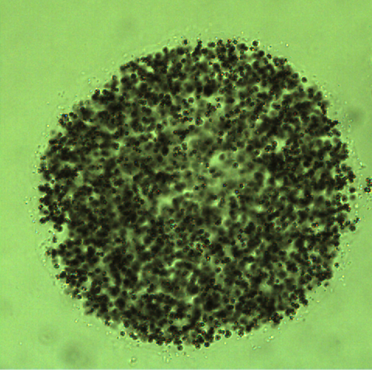

Phylum: Cyanobacteriophyta
Class: Cyanophyceae
Order: Chroococcales

Habitat: planktonic, pelagic
Distinctive features: the main bloom-forming species of Microcystis in Lake Kinneret
Organization: colonial
Color: green or brown
Cell shape: sphere
Colony shape: mostly spherical
Cell diameter (D): 2 – 6.5 μm, median: 3 μm (N=3200)
Cell biovolume: 2.5 – 150 μm³, median: 14 μm³
Biovolume equation: Sphere, V = 4/3 π (D/2)³
Colony diameter: ~ 50 -200 µm
Cells per colony: 30-7000; median 270

Morphological features: Colonies microscopic, compact, more or less shperical, globose, obovoid, ellipsoidal or irregular in outline but not lobate, with densely packed spherical cells, only rarely with indistinct holes in older colonies. Mucilage indistinct, fine, hyaline, colorless, diffluent. Mucilaginous envelopes not exceediing the margin of the colony by more than 1 µm. Cells spherical or hemispherical when dividing, with aerotopes, ~3 µm in diameter. This species may be confused with young colonies of Microcystis aeruginosa. It differes by its more compact arrangement of cells without holes in mature colonies and propagation of colonies (McGregor et al. 2007).

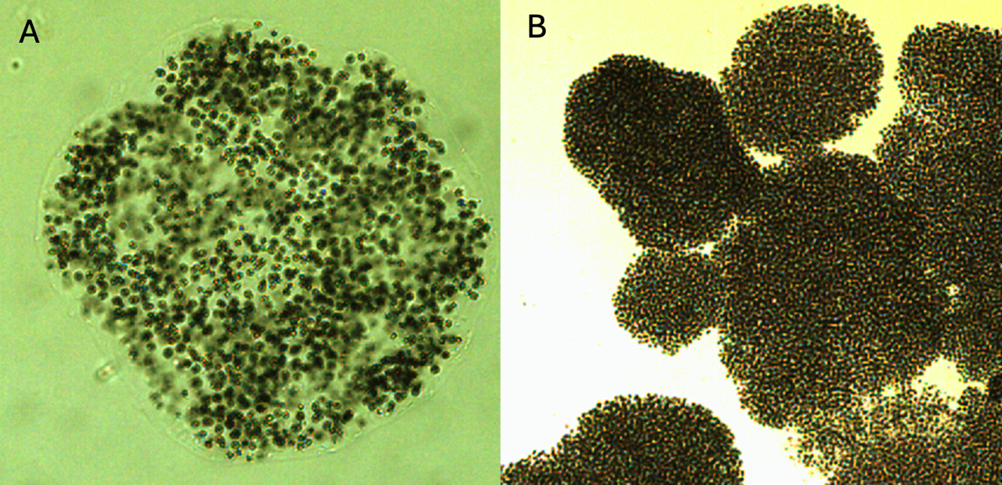
Plate 1. Microcystis flos-aquae from Lake Kinneret, showing the densely packed cells in a colony. A- mucilage and its boundaries are apparent. B. several colonies in lower magnification. Photos by Alla Alster, May 2006.
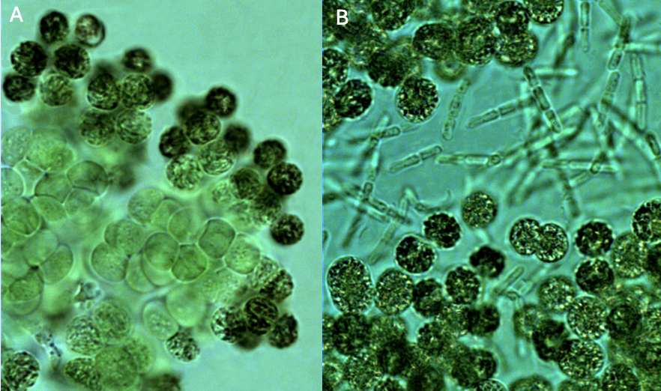
Plate 2. Microcystis flos-aquae from Lake Kinneret at higher magnification. A. Darker cells around colony periphery, lighter color cells in the colony center. B. a colony colonized by Pseudanabaena mucicola filaments. Photos by Alla Alster, Nov. 2006, Sta. A.
Ecology:
Microcystis flos-aquae is the most abundant species of the genus Microcystis occurring in Lake Kinneret. It formed a major bloom in 1964 (Pollingher and Kimor 1970), was a common component of the phytoplankton in the early 1970s (Fig. 1), then declined to near-elimination during the 1980s and early 1990s (Fig. 1). Then, in January 1995 it re-appeared in huge abundance, forming a major bloom, several months after the first ever bloom of Aphanizomenon ovalisporum in fall 1994. Since then it is present in the water most of the time, at higher abundance in winter (Fig. 2), especially in winters when Peridinium gatunense fails to bloom. On calm winter days it floats to the surface where it accumulates and forms thin films that are pushed by gentle winds to lee shores where it accumulates.
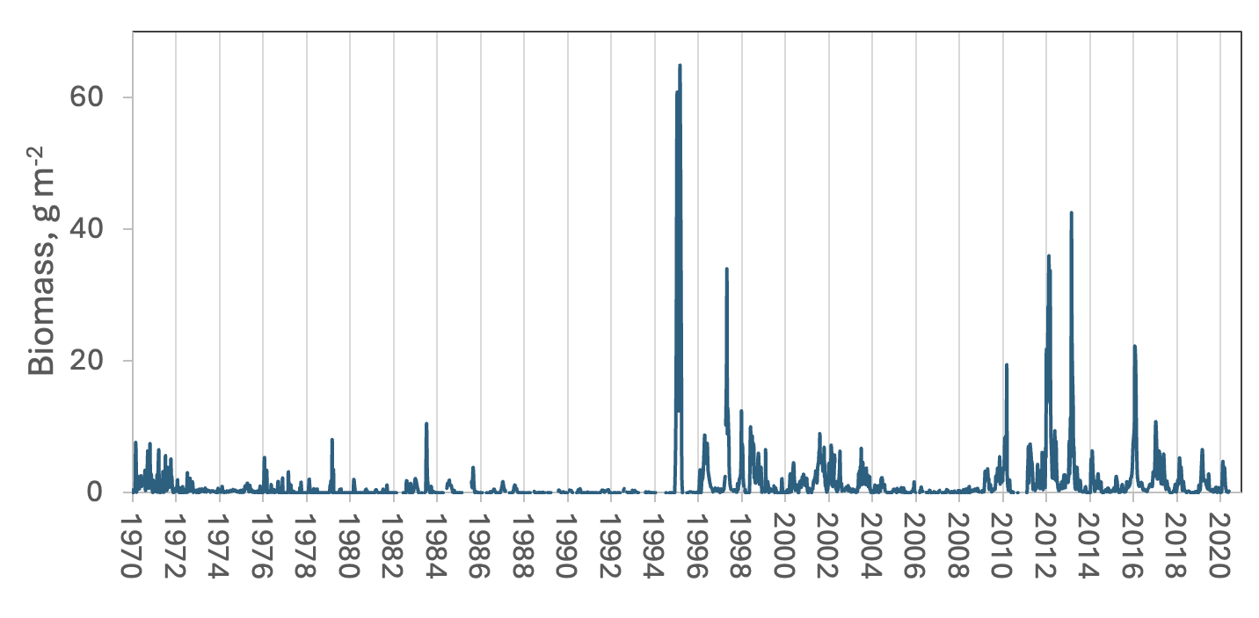
Figure 1. Time series of Microcystis flos-aquae depth-integrated biomass (g m⁻²), Lake Kinneret, 1970-2020.
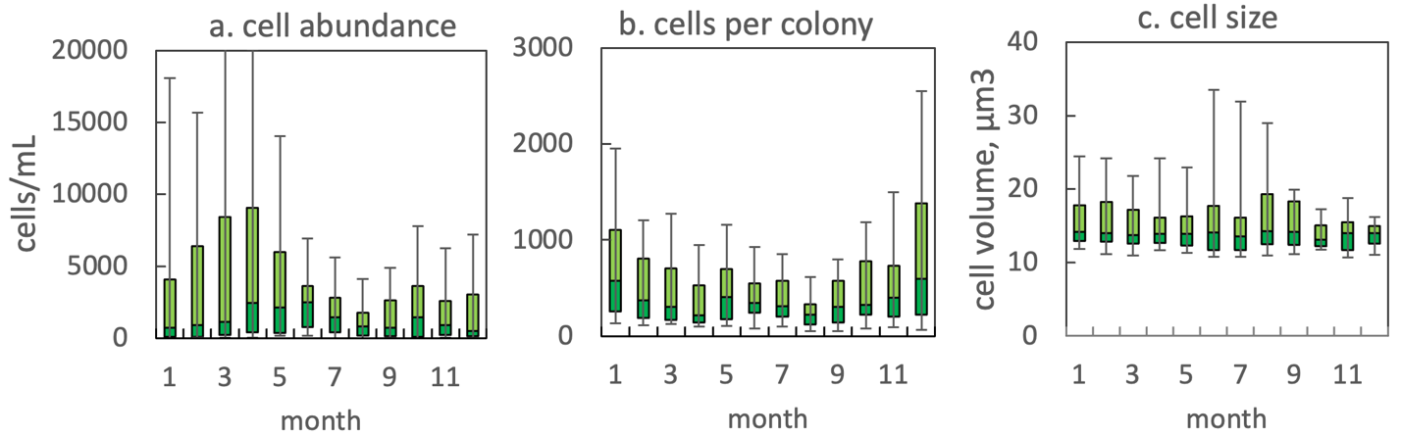
Figure 2. The annual pattern of Microcystis flos-aquae parameters, based on data for 1996-2020: (a) water column cell abundance; (b) number of cells per colony; (c) cell volume. Statistics shown are median – middle line; 25th to 75th percentiles – box content; 90th and 10th percentiles - top and bottom bars, respectively.
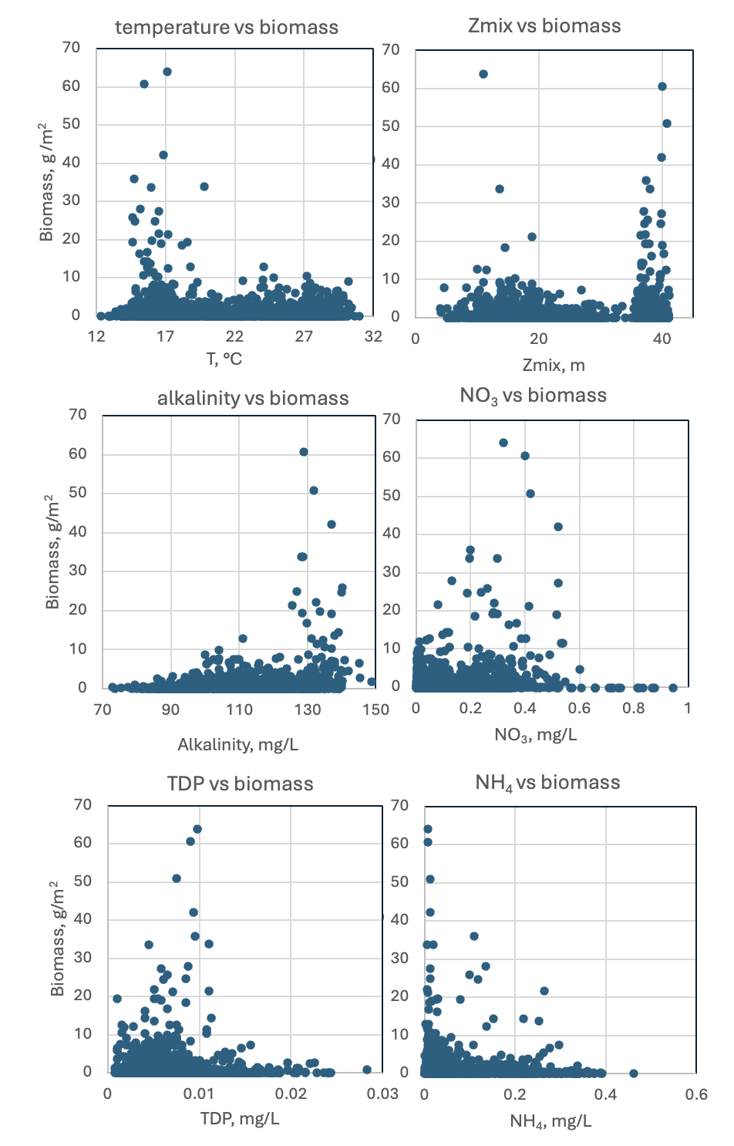
Fig. 3. Microcystis flos aqua depth-integrated biomass (g wet weight m⁻²) vs. environmental parameters recorded at the site and time of sampling. Based on data for 1970-2020.
Physiological features: Microcystis flos aqua is the main producer of microcystins in Lake Kinneret.
Darker cells around colony periphery, lighter color cells in the colony center (Plate 2A). The peripheral cells are more heavily pigmented and gas-vacuolated, to protect inside cells from photooxydation near the surface. It was hypothesized that these inner cells are subjected to a low-oxygen environment and may fix atmospheric N₂, but this requires experimental confirmation.
Environmental conditions:
M. flos-aquae biomass was independent of water level, chloride concentration, pH, dissolved oxygen, nitrate. It was higher when mixing depth was > 35 m (destratification); when water temperature < 20°C; alkalinity > 120 mg L⁻¹; Ca > 50 mg L⁻¹; at lower DON, NH₄ (Fig. 3).
Cite this record as:
Tamar Zohary, Alla Alster. [Date when Item was last updated]. Electronic publication. Israel Oceanographic & Limnological Research. [Date when last accessed].
Further reading:
Kaplan-Levy RN, Alster-Gloukhovski A, Benyamini Y, Zohary T. 2016. Lake Kinneret phytoplankton: integrating classical and molecular taxonomy. Hydrobiologia 764(1):283-302.
Komárek J, Anagnostidis K. 1999. Cyanoprokaryota. 1. Chroococcales. In: Süßwasserflora von Mitteleuropa. Begründet von A. Pascher. Band 19/1. (Ettl H, Gärtner G, Heynig H, Mollenhauer D, Eds), pp. 1-548. Heidelberg & Berlin: Spektrum, Akademischer Verlag.
McGregor G, Fabbro LD, Lobegeiger JS. 2007. Freshwater planktic Chroococcales (Cyanoprokaryota) from North-Eastern Australia: a morphological evaluation. Nova Hedwigia 84(3/4): 299-331.
Pollingher U, Kimor B. 1970. Seasonal and bathymetric changes in the composition of the phytoplankton populations of Lake Tiberias based on biomass estimations during the years 1964-1967. State of Israel, Ministry of Agriculture, Department of Fisheries, Sea Fisheries Research Station.
Zohary T, Yacobi YZ, Alster A, Fishbein T, Lippman S, Tibor G. 2014. Phytoplankton. Chap. 10 In: Zohary T, Sukenik A, Berman T, Nishri A. [eds] Lake Kinneret: Ecology and Management, pp. 161-190. Springer, Heidelberg.

